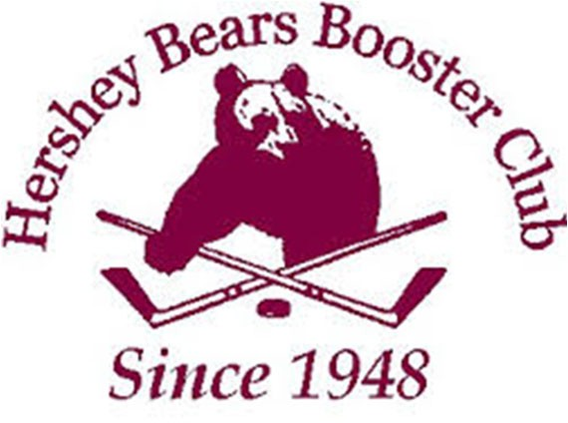
Hershey Bears Booster Club Membership Application

(Print, fill out and submit)

I hereby apply for membership in the Hershey Bears Booster Club and if accepted will faithfully comply with and agree to adhere to all by-laws and regulations adopted by the club.

NAME NAME

ADDRESS CITY STATE ZIP CODE_

PHONE PHONE

DATE & MONTH OF BIRTH DATE & MONTH OF BIRTH

E-MAIL ADDRESS E-MAIL ADDRESS

Cost of Membership: $15.00

Make checks or money order (PLEASE do not send cash through the mail) Payable to “Hershey Bears Booster Club” or simply “HBBC” and mail to:

Hershey Bears Booster Club Attn: Membership Secretary PO Box 15
Hershey, PA 17033

-OR-

Membership can be paid at the Booster Club table behind Section 119 at any Hershey Bears Regular Season home game, or you can renew at any General Business Meeting.

***Note: You may pay cash or check at the games or meetings***

Applicants must be 18 years of age or older.

Membership runs from Sign-up Date through December 1st of the following season.

HBBC Memberships are non-transferrable.

